Ex. No.: 11

DATABASE WITH AUTO_INCREMENT SEQUENCES
AIM:

To create Auto Increment sequence on the given relation.

Questions:
- Populate register number using auto increment in DBMS_Stud table.
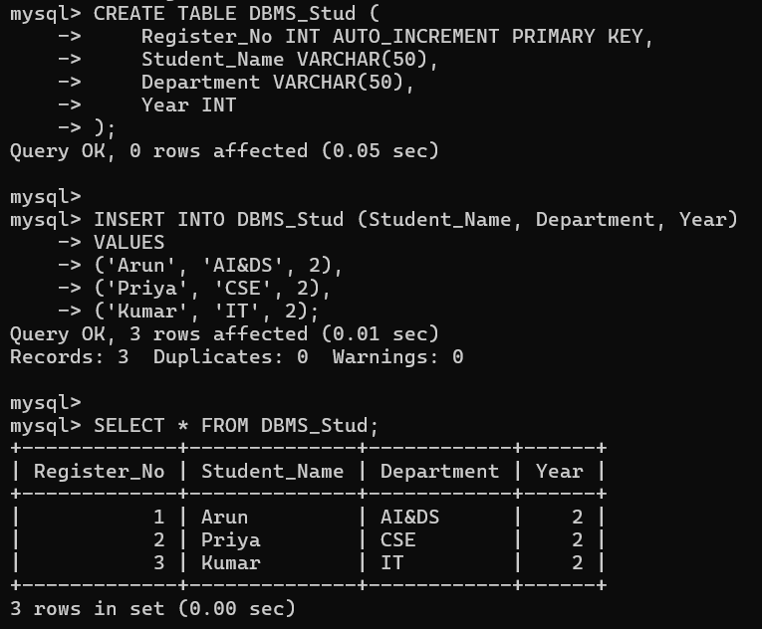
- Manually populate register number
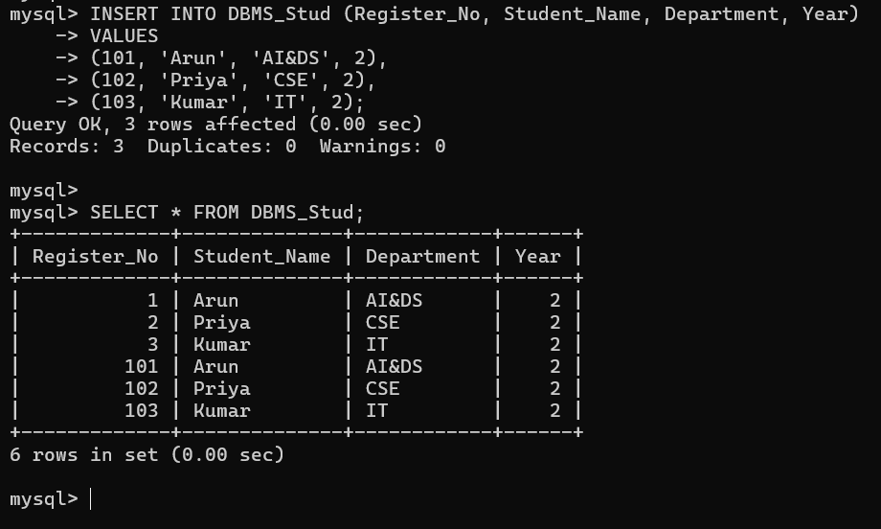
- Drop the auto increment.
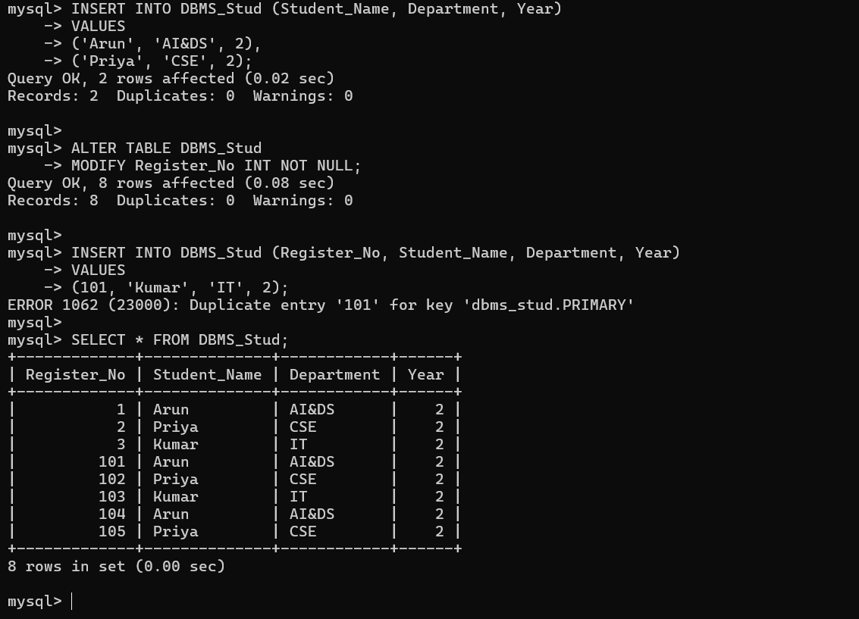

RESULT:

The records from the tables are displayed using auto_incrementsequence on the given relation.

